Geometry
# Source: AI Source: Provided by: [Data Path: Persons Table -> ID Column: 1, Name_En Column: Motasem Essam] -> From: [ChatGPT] on [7/20/2026]
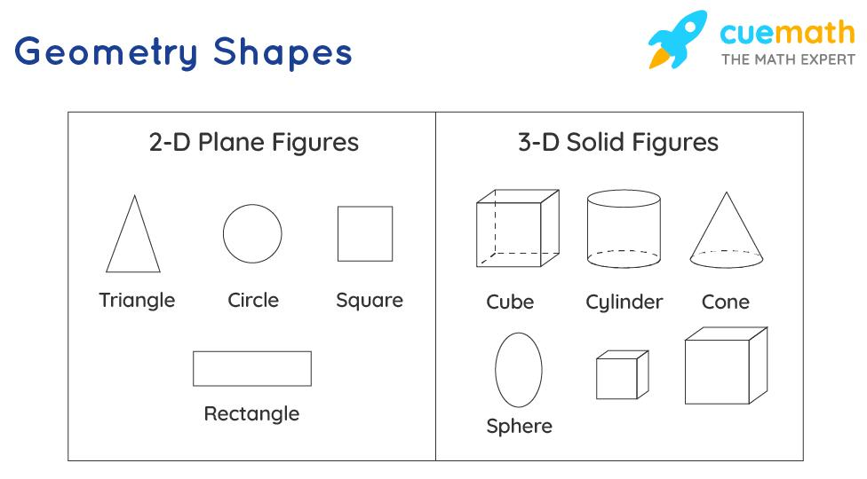
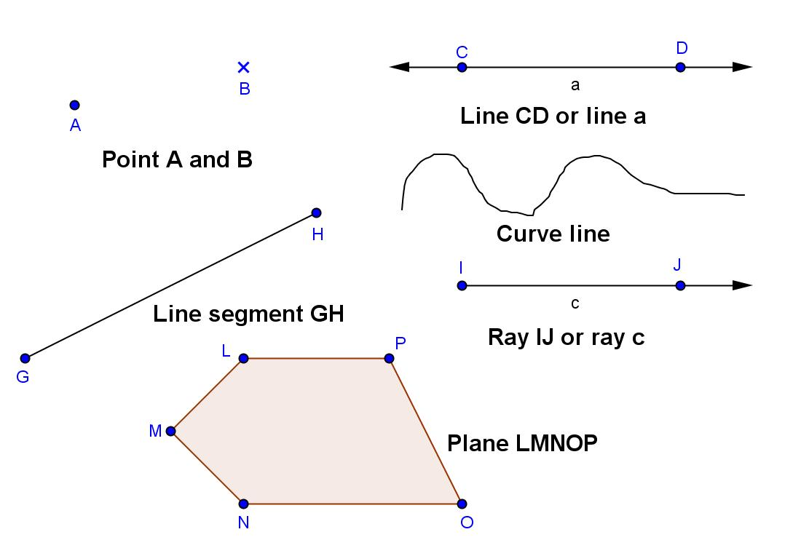
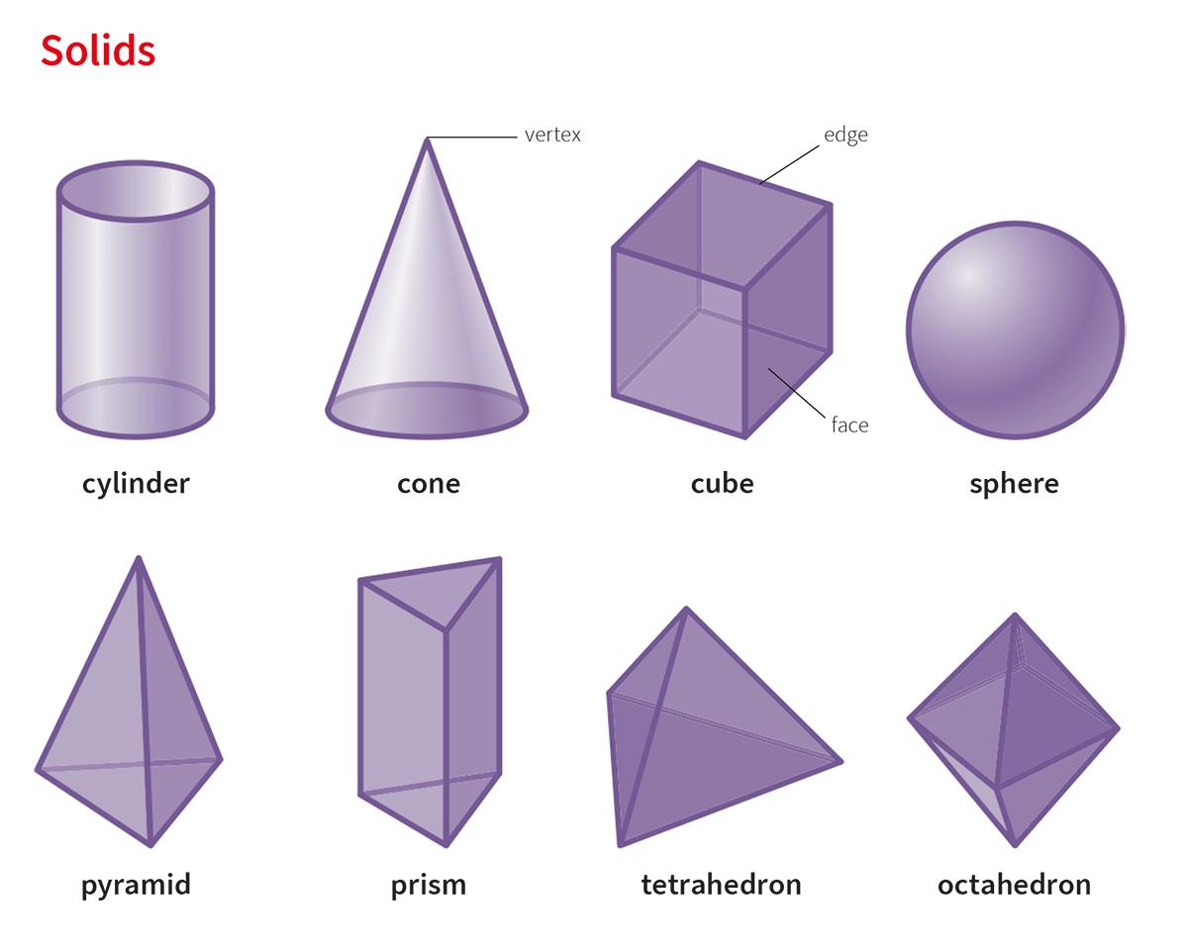
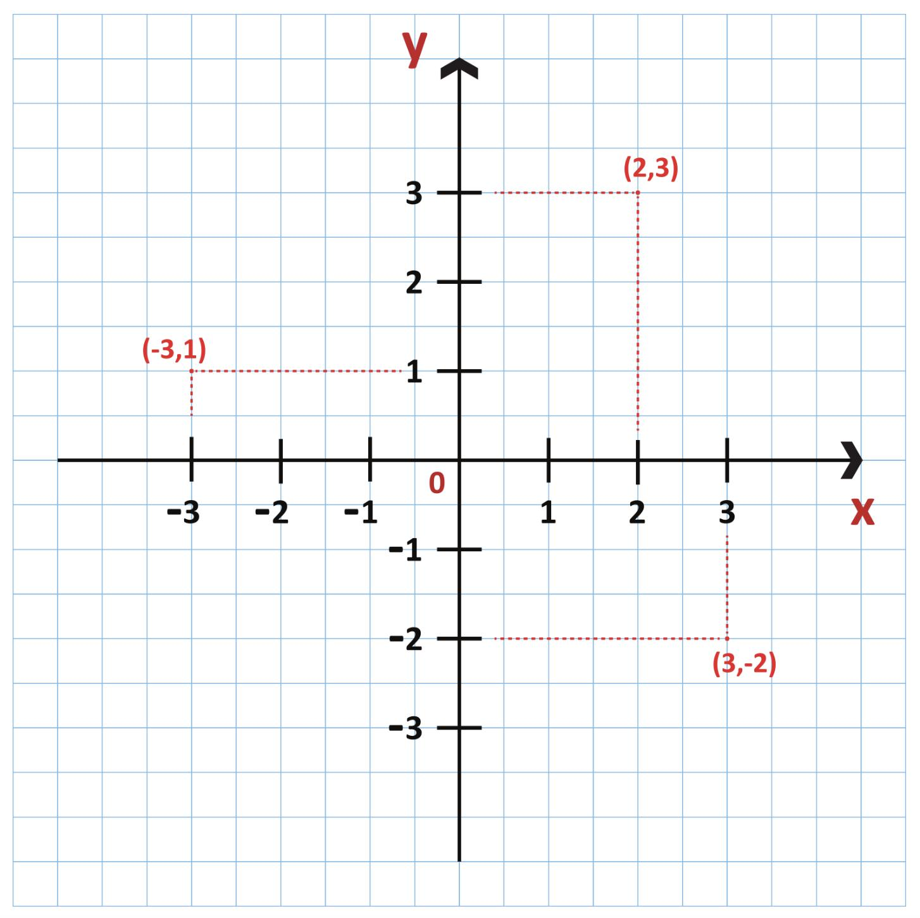
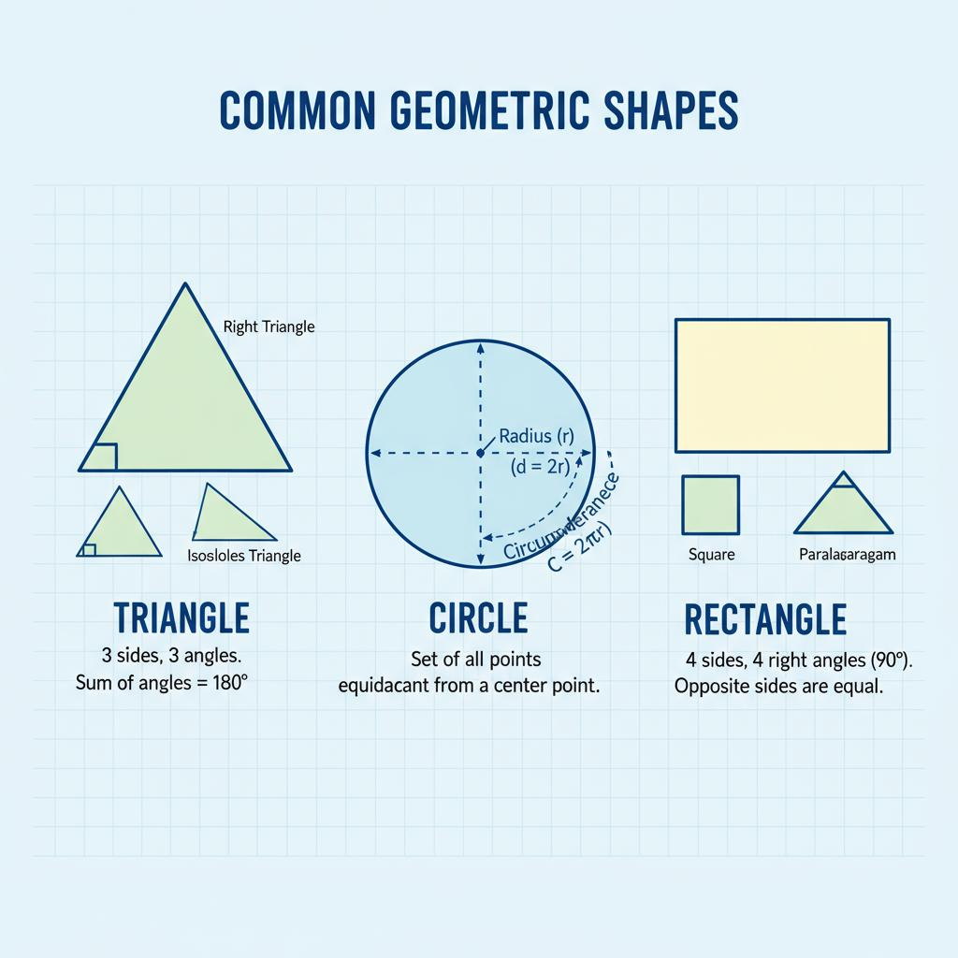
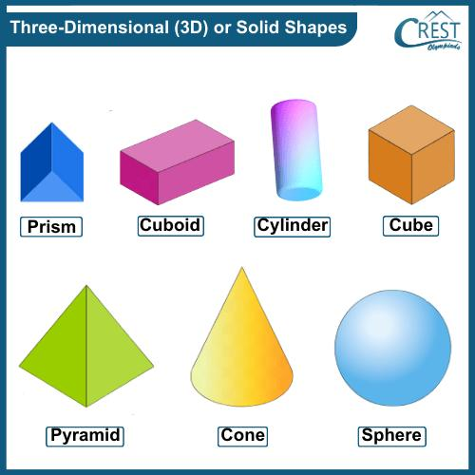

Definition
# Source: AI Source: Provided by: [Data Path: Persons Table -> ID Column: 1, Name_En Column: Motasem Essam] -> From: [ChatGPT] on [7/20/2026]
Geometry is the branch of mathematics that studies the shape, size, position, distance, angles, and properties of points, lines, surfaces, and solids. It explains the relationships between geometric figures and provides methods for measuring and analyzing them.
The word Geometry comes from the Greek words:
- Geo = Earth
- Metron = Measurement
meaning "measurement of the Earth."

Purpose
# Source: AI Source: Provided by: [Data Path: Persons Table -> ID Column: 1, Name_En Column: Motasem Essam] -> From: [ChatGPT] on [7/20/2026]
Geometry is used to:
- Measure lengths, areas, and volumes.
- Analyze shapes and spatial relationships.
- Design buildings and engineering structures.
- Create maps and technical drawings.
- Solve navigation and surveying problems.
- Support computer graphics and 3D modeling.

Main Branches of Geometry

1. Plane Geometry (2D Geometry)
# Source: AI Source: Provided by: [Data Path: Persons Table -> ID Column: 1, Name_En Column: Motasem Essam] -> From: [ChatGPT] on [7/20/2026]
Studies flat figures that have only length and width.
Examples:
- Points
- Lines
- Angles
- Triangles
- Circles
- Polygons

2. Solid Geometry (3D Geometry)
# Source: AI Source: Provided by: [Data Path: Persons Table -> ID Column: 1, Name_En Column: Motasem Essam] -> From: [ChatGPT] on [7/20/2026]
Studies three-dimensional objects that have:
- Length
- Width
- Height
Examples:
- Cube
- Sphere
- Cylinder
- Cone
- Prism
- Pyramid

3. Coordinate Geometry (Analytic Geometry)
# Source: AI Source: Provided by: [Data Path: Persons Table -> ID Column: 1, Name_En Column: Motasem Essam] -> From: [ChatGPT] on [7/20/2026]
Studies geometric figures using the Cartesian coordinate system.
Applications:
- Graphing equations
- Distance calculations
- Midpoint calculations
- Line equations

4. Euclidean Geometry
# Source: AI Source: Provided by: [Data Path: Persons Table -> ID Column: 1, Name_En Column: Motasem Essam] -> From: [ChatGPT] on [7/20/2026]
Based on the axioms established by the Greek mathematician Euclid.
Features:
- Flat space
- Parallel lines never meet
- Most school geometry is Euclidean.

5. Non-Euclidean Geometry
# Source: AI Source: Provided by: [Data Path: Persons Table -> ID Column: 1, Name_En Column: Motasem Essam] -> From: [ChatGPT] on [7/20/2026]
Studies curved spaces where Euclid's parallel postulate does not apply.
Examples:
- Spherical Geometry
- Hyperbolic Geometry
Applications:
- Astronomy
- Navigation
- General Relativity

Fundamental Geometric Elements
# Source: AI Source: Provided by: [Data Path: Persons Table -> ID Column: 1, Name_En Column: Motasem Essam] -> From: [ChatGPT] on [7/20/2026]
- Point
- Line
- Line Segment
- Ray
- Angle
- Plane
- Surface
- Solid

Common Geometric Shapes

Two-Dimensional Shapes
# Source: AI Source: Provided by: [Data Path: Persons Table -> ID Column: 1, Name_En Column: Motasem Essam] -> From: [ChatGPT] on [7/20/2026]
- Triangle
- Square
- Rectangle
- Circle
- Parallelogram
- Rhombus
- Trapezoid
- Pentagon
- Hexagon
- Octagon

Three-Dimensional Shapes
# Source: AI Source: Provided by: [Data Path: Persons Table -> ID Column: 1, Name_En Column: Motasem Essam] -> From: [ChatGPT] on [7/20/2026]
- Cube
- Cuboid
- Sphere
- Cylinder
- Cone
- Pyramid
- Prism
- Torus

Measurements in Geometry
# Source: AI Source: Provided by: [Data Path: Persons Table -> ID Column: 1, Name_En Column: Motasem Essam] -> From: [ChatGPT] on [7/20/2026]
Geometry commonly involves measuring:
- Length
- Distance
- Perimeter
- Area
- Surface Area
- Volume
- Angle
- Radius
- Diameter
- Circumference

Common Formulas
# Source: AI Source: Provided by: [Data Path: Persons Table -> ID Column: 1, Name_En Column: Motasem Essam] -> From: [ChatGPT] on [7/20/2026]
Rectangle Area
$$A=l×w$$

Square Area
$$A=s^{2}$$

Triangle Area
$$A=\frac{1}{2}bh$$

Circle Area
$$A=πr^{2}$$

Circle Circumference
$$C=2πr$$

Cube Volume
$$V=s^{3}$$

Rectangular Prism Volume
$$V=lwh$$

Sphere Volume
$$V=\frac{4}{3}πr^{3}$$

Pythagorean Theorem
$$a^{2}+b^{2}=c^{2}$$

Applications
# Source: AI Source: Provided by: [Data Path: Persons Table -> ID Column: 1, Name_En Column: Motasem Essam] -> From: [ChatGPT] on [7/20/2026]
Geometry is used in:
- Architecture
- Civil engineering
- Mechanical engineering
- Surveying
- Cartography
- Manufacturing
- Robotics
- Computer graphics
- Computer-aided design (CAD)
- Astronomy
- Navigation

Advantages
# Source: AI Source: Provided by: [Data Path: Persons Table -> ID Column: 1, Name_En Column: Motasem Essam] -> From: [ChatGPT] on [7/20/2026]
Geometry:
- Improves spatial reasoning.
- Supports engineering design.
- Enables accurate measurement.
- Helps visualize structures.
- Forms the foundation of many scientific fields.

Limitations
# Source: AI Source: Provided by: [Data Path: Persons Table -> ID Column: 1, Name_En Column: Motasem Essam] -> From: [ChatGPT] on [7/20/2026]
Geometry:
- Often assumes ideal shapes.
- Requires measurement precision.
- Real-world objects may deviate from perfect geometric models.

Key Points
# Source: AI Source: Provided by: [Data Path: Persons Table -> ID Column: 1, Name_En Column: Motasem Essam] -> From: [ChatGPT] on [7/20/2026]
- Geometry studies shapes and space.
- It includes:
  - Plane Geometry
  - Solid Geometry
  - Coordinate Geometry
  - Euclidean Geometry
  - Non-Euclidean Geometry
- It provides formulas for measuring:
  - Length
  - Area
  - Volume
  - Angles
- Geometry is fundamental to engineering, architecture, surveying, science, and technology.

Conclusion
# Source: AI Source: Provided by: [Data Path: Persons Table -> ID Column: 1, Name_En Column: Motasem Essam] -> From: [ChatGPT] on [7/20/2026]
Geometry is the mathematical study of shapes, sizes, positions, and spatial relationships. From simple lines and triangles to complex three-dimensional solids and curved spaces, geometry provides the principles and formulas needed to measure, analyze, and design the physical world. It is one of the foundational branches of mathematics and plays an essential role in engineering, architecture, construction, navigation, computer graphics, scientific research, and everyday problem-solving.

